

Egypt University of Informatics

Computer and Information Systems

Data Analysis Course

Analyzing the Determinants of Apartment Prices:

Insights from Payment Methods, Bedrooms, Furnishing Status, and Location

Team Name: Random Team 1

Team Members: Hazem Refaat 21-101105

Amr Ahmed Morsi 22-101237

Ahmed Mohamed Badr 22-101101

Yassine El-Sheikh 22-101161

Mohamed Ahmed Hamdy 22-101125

26-5-2024

Abstract:

This report investigates the determinants of apartment prices in the real estate market, focusing on key factors such as payment methods, the number of bedrooms, furnishing status, and location. By analyzing a comprehensive dataset, this study aims to derive insights that aid in data-driven decision-making for buyers, sellers, and investors. The analysis confirms that payment methods, bedroom count, furnishing status, and city location significantly impact apartment prices, with notable price variations observed across different cities.

Introduction:

The real estate market is highly dynamic, with various factors influencing apartment prices. Understanding these determinants is crucial for making informed decisions. This study focuses on four primary factors: payment methods, the number of bedrooms, furnishing status, and location. By examining these variables, we aim to provide a clear understanding of how each factor affects apartment prices, thus aiding stakeholders in the real estate market.

Research Question:

What are the key determinants of apartment prices, and how do different factors such as payment methods, the number of bedrooms, furnishing status, and location influence these prices?

Hypotheses:

**Payment Method Hypothesis:** Apartments purchased with cash are cheaper than those purchased with instalments.

**Bedrooms Hypothesis:** Apartments with more than two bedrooms are significantly more expensive than those with two or fewer bedrooms.

**Furnishing Status Hypothesis:** Furnished apartments have a higher median price compared to unfurnished apartments.

**City-wise Price Variability Hypothesis:** There is significant price variability across the top three cities with the highest number of apartments listed.

Dataset

The dataset used in this analysis is a CSV file named **combined.csv**, containing the following key columns:

* **Price**: The price of the apartment.
* **Bedrooms**: The number of bedrooms in the apartment.
* **Bathrooms**: The number of bathrooms in the apartment.
* **Area**: The area of the apartment in square feet.
* **Payment Option**: The payment method (e.g., Cash, Installment).
* **Furnished**: Indicates whether the apartment is furnished (Yes/No).
* **City**: The city where the apartment is located.

Sampling Method:

**Random sampling**: Every apartment listing has an equal chance of being included.

Population of interest:

|  |  |
| --- | --- |
| **Buyers and sellers** of the collection of apartment listings contained within the | |
| **‘combined.csv’** dataset. |  |

Data Pre-processing:

The data preprocessing steps included:

**Cleaning**: Removing any missing or irrelevant data.

**Normalization**: Standardizing numerical values to a common scale.

**Encoding**: Converting categorical variables into numerical formats for analysis.

Analysis

**Payment method analysis**: To test the hypothesis that cash purchases are cheaper than installment purchases, we conducted a comparative analysis of apartment prices based on payment methods. The results showed that apartments purchased with cash had a lower median price compared to those purchased with installments.

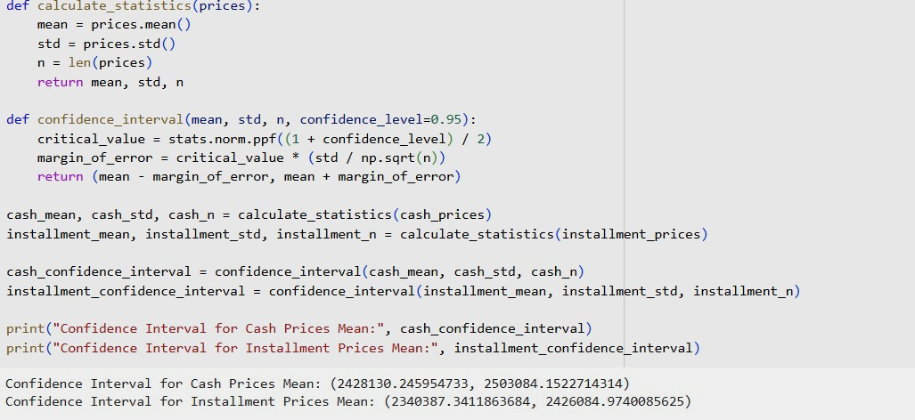

**Bedrooms Analysis:** A KDE plot and histogram were used to visualize the impact of the number of bedrooms on apartment prices. The analysis supports the hypothesis that apartments with more than two bedrooms are significantly more expensive than those with two or fewer bedrooms. This trend was consistent across different cities.

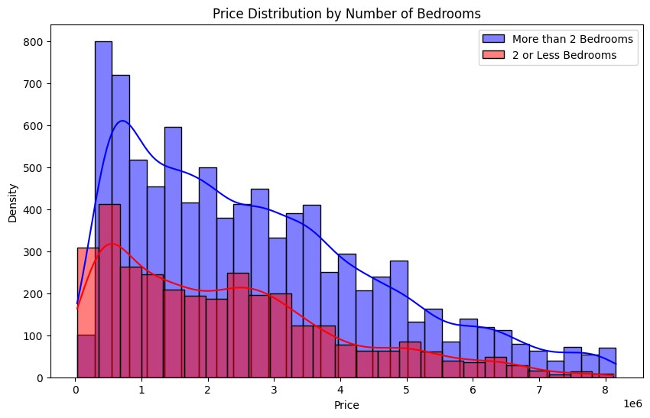

**Furnishing Status Analysis**: We examined the impact of furnishing status on apartment prices. The results indicated that furnished apartments have a higher median price compared to unfurnished apartments, supporting the hypothesis.

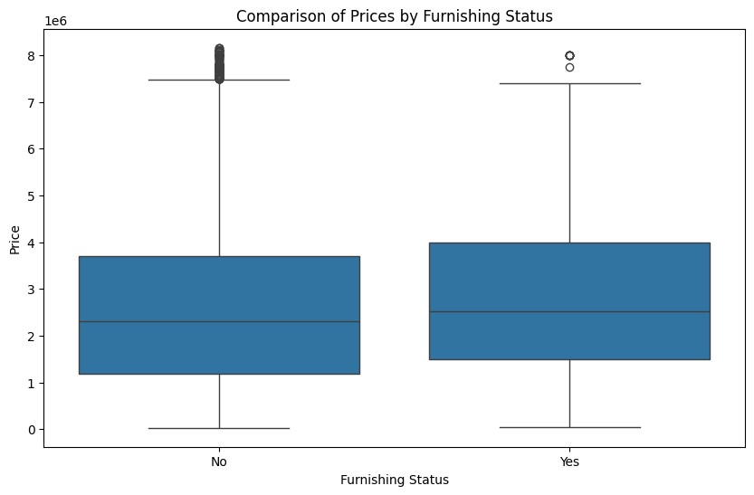

**City-wise Price Variability**: A box plot was used to illustrate the price variability across different cities. The analysis showed significant differences, with New Cairo - El Tagamoa having the highest median prices and 6th of October showing the greatest price variability. This insight is crucial for making data-driven decisions for buyers and investors in the real estate market.

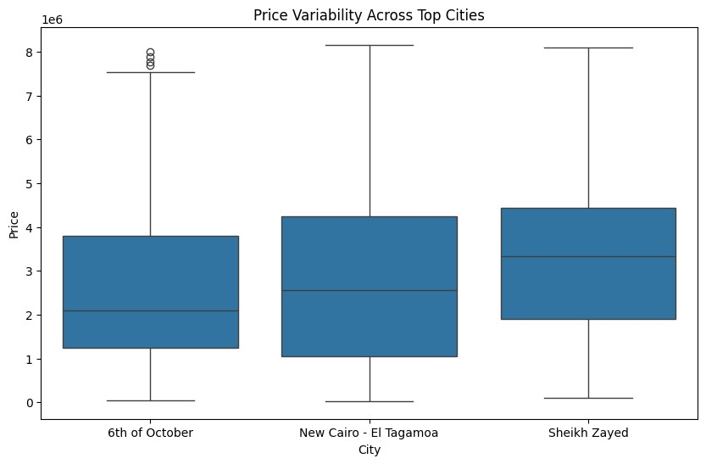

Key Findings

1. **Payment Method Analysis**

Observation: Apartments purchased with cash tend to have a lower median price compared to those purchased with instalments.

Implication: Buyers opting for cash payments can potentially secure lower prices, suggesting a cost-saving advantage for cash buyers.

1. **Bedrooms Analysis**:

Observation: Apartments with more than two bedrooms are significantly more expensive than those with two or fewer bedrooms. This trend is consistent across different cities.

Implication: The number of bedrooms is a strong determinant of apartment prices. Larger apartments with more bedrooms are valued higher, reflecting their greater appeal to families and larger households.

1. **Furnishing Status Analysis**:

Observation: Furnished apartments have a higher median price compared to unfurnished apartments.

Implication: Furnishing status adds value to the property, making furnished apartments more attractive and therefore more expensive. This could be due to the convenience and immediate liveability offered by furnished apartments.

1. **City-wise Price Variability**:

Observation: Significant price variability exists across different cities. For exampl e, New Cairo - El Tagamoa has the highest median prices, while 6th of October shows the greatest price variability.

Implication: Location is a critical factor in determining apartment prices. Cities like New Cairo - El Tagamoa are likely more desirable, possibly due to better infrastructure, amenities, and overall living conditions. The variability in 6th of October suggests a diverse range of property values within the city.

1. **General Trends**:

Price Distribution: The price distribution shows a wide range of prices across different categories, indicating a diverse real estate market with options catering to various budget levels.

High-value Outliers: There are significant high-value outliers in the dataset, especially in cities like New Cairo - El Tagamoa, indicating the presence of luxury apartments that command premium prices.

Conclusion

The analysis highlights the importance of payment methods, the number of bedrooms, furnishing status, and city location as key determinants of apartment prices. These findings provide valuable insights for buyers, sellers, and investors, enabling more informed decisions in the real estate market. The variability in prices based on these factors underscores the need for a nuanced approach when assessing property values.

# Potential Issues

Missing Values:

Despite cleaning the data, some entries still had missing values for critical columns such as price, area, and furnishing status, which may affect the robustness of the analysis.

Inaccurate Entries:

There may be inaccuracies in the dataset that were not identified during preprocessing, which could lead to incorrect conclusions.

Sampling Bias:

**Limited Geographic Representation:** The dataset may not evenly represent all regions, especially less popular cities, leading to skewed results towards more prominent cities.

External Factors:

**Economic Conditions:** Changes in economic conditions, such as inflation or changes in interest rates, were not accounted for, which could influence apartment prices.

**Government Policies:** New government policies or changes in existing policies regarding real estate could impact prices and were not considered in the analysis.

Furnishing Status Ambiguity:

**Categorization:** The dataset has entries marked as 'Unknown' for the furnishing status, which were excluded. This exclusion might bias the results since 'Unknown' could represent a significant portion of the data.

**Inconsistent Definitions:** The definition of 'furnished' and 'unfurnished' may vary between listings, leading to potential inconsistencies in the analysis.

|  |  |
| --- | --- |
| Price Outliers | : |
| **High-value Properties** | |

**:** The presence of high-value properties (outliers) can skew the

analysis. While they were included to maintain the dataset's integrity, they could disproportionately influence the results.

Data Timeliness:

**Outdated Data:** The data might not reflect the most current market conditions if there have been recent changes in the real estate market.

Discussion

The objective of this study was to analyze the determinants of apartment prices in the real estate market, focusing on key factors such as payment methods, the number of bedrooms, furnishing status, and location. The analysis utilized a comprehensive dataset to derive insights that can aid in data-driven decision-making for buyers, sellers, and investors.

Payment Method Analysis

The analysis revealed that apartments purchased with cash generally have a lower median price compared to those purchased with installments. This finding aligns with the hypothesis that cash purchases are cheaper than installment purchases. The box plot analysis showed that while cash payments tend to have a lower median price, the range of prices is quite broad. This could be attributed to the immediate liquidity provided by cash payments, which may incentivize sellers to offer lower prices. On the other hand, installment payments, which spread the cost over time, might include interest and financing charges, leading to higher overall prices. This insight suggests that buyers with the capability to make cash payments might achieve cost savings.

Bedrooms Analysis

The number of bedrooms was found to be a significant determinant of apartment prices. Apartments with more than two bedrooms are generally more expensive than those with two or fewer bedrooms. The KDE plot and histogram provided clear visual evidence supporting this hypothesis. This trend was consistent across different cities, indicating that larger apartments are valued higher due to their ability to accommodate more people and provide additional space. This is particularly important for families or individuals seeking more spacious living conditions. The presence of significant outliers, especially in apartments with more than four bedrooms, suggests the inclusion of luxury apartments in the dataset. These highvalue properties skew the price distribution, highlighting the premium placed on larger living spaces.

Furnishing Status Analysis

The analysis showed that furnished apartments have a higher median price compared to unfurnished apartments. This supports the hypothesis that furnishing status adds value to the property. Furnished apartments offer immediate livability and convenience, which can attract buyers willing to pay a premium for these advantages. The box plot analysis illustrated that furnished apartments not only have a higher median price but also exhibit a wider range of prices, indicating a market with diverse furnishing levels and qualities. This finding underscores the importance of furnishing status as a selling point and its impact on market valuation.

City-wise Price Variability

There was significant price variability observed across different cities. New Cairo - El Tagamoa, for instance, had the highest median prices, while 6th of October exhibited the greatest price variability. The box plot analysis highlighted these differences, showing a broad range of prices within each city. This variability can be attributed to factors such as location desirability, infrastructure development, availability of amenities, and overall living conditions. Cities like New Cairo - El Tagamoa likely attract higher prices due to better infrastructure, high demand, and a concentration of upscale developments. The diverse range of prices in 6th of October suggests a mix of high-end and more affordable properties, reflecting a varied market catering to different segments of buyers.

General Trends

The general trends observed from the dataset included a wide range of apartment prices across different categories, indicating a diverse real estate market. High-value outliers were particularly notable in cities like New Cairo - El Tagamoa, suggesting the presence of luxury apartments that command premium prices. These outliers significantly influence the overall price distribution, emphasizing the importance of considering property type and market segment when analyzing real estate prices.

Conclusion

The study successfully identified key determinants of apartment prices in the real estate market, highlighting the significant impact of payment methods, the number of bedrooms, furnishing status, and city location. The findings have several implications:

For Buyers: Understanding that cash payments can potentially secure lower prices and recognizing the premium associated with furnished apartments can help buyers make informed purchasing decisions.

For Sellers: Highlighting the benefits of cash payments to attract buyers and strategically pricing furnished apartments can optimize sales strategies. Sellers in high-demand cities like New Cairo - El Tagamoa can leverage the desirability of the location to command higher prices.

For Investors: Identifying cities with high price variability, such as 6th of October, provides opportunities for investment in both luxury and affordable housing segments. Investors can also focus on larger apartments with more bedrooms, which tend to have higher values.

The analysis underscores the importance of considering multiple factors when assessing apartment prices. While payment method, number of bedrooms, furnishing status, and location are crucial, it is also important to account for external factors such as economic conditions and government policies. Future research could explore more sophisticated modeling techniques to provide deeper insights and consider additional variables to enhance the robustness of the analysis.

By providing a comprehensive understanding of the determinants of apartment prices, this study contributes valuable knowledge to the real estate market, aidi ng in datadriven decision-making for all stakeholders involved.